1) Watch ansible-01 video and write down notes.

2) Setup one master and two worker nodes in ansible.

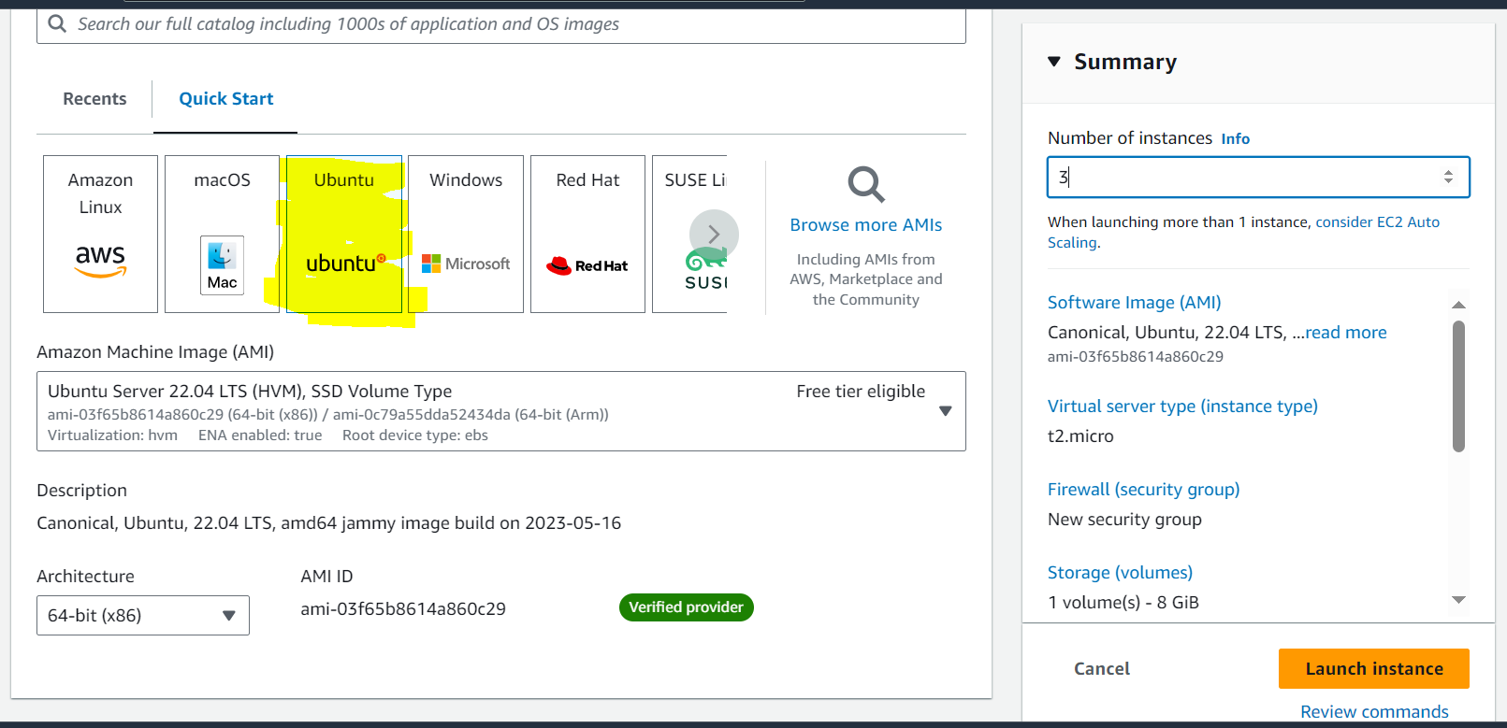

**then procedure to install Ansible in Master server**

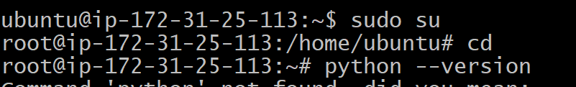

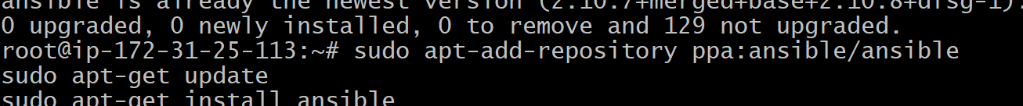

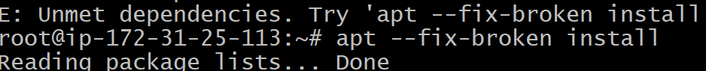

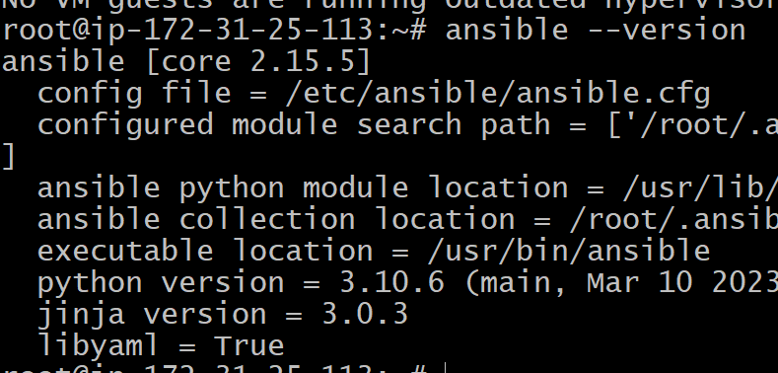

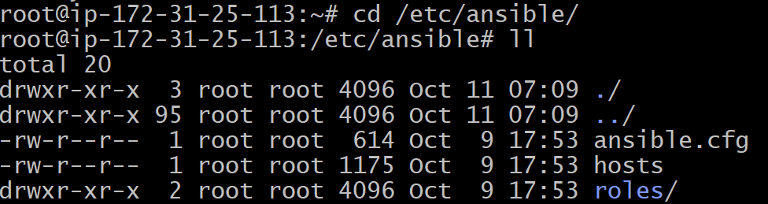

**mention workers public IP in master Host file with Group [all]**

**Then see the Host ips by cat**

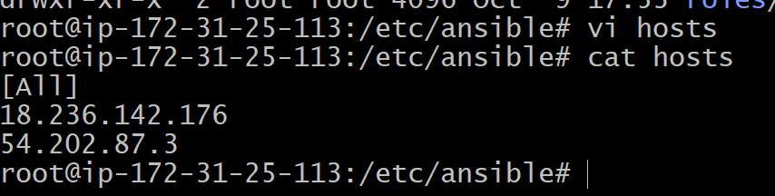

**then generate SSH keygen in Master ansible server**

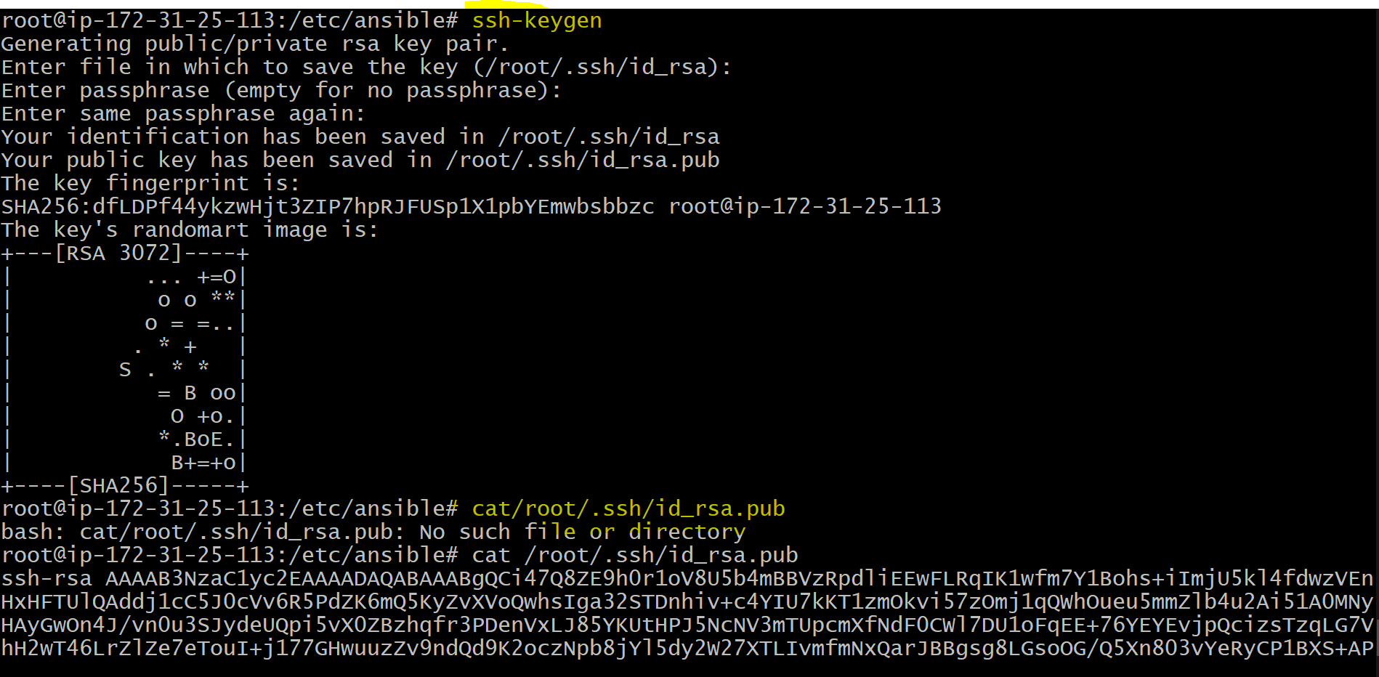

**procedure to add ssh pub key in workers server**

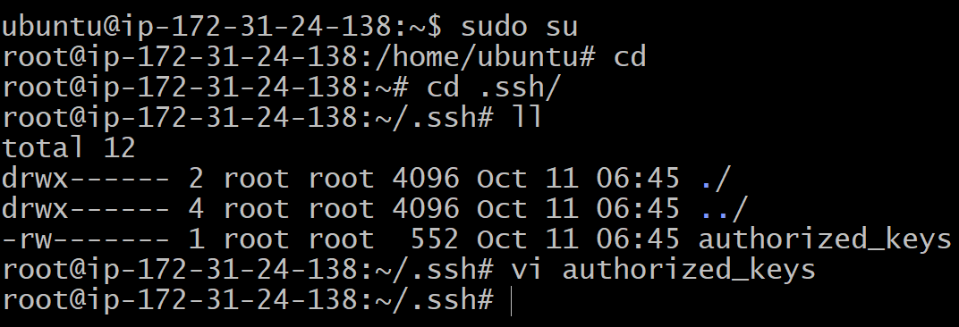

**then paste in worker server ~.ssh/authorized_key file**



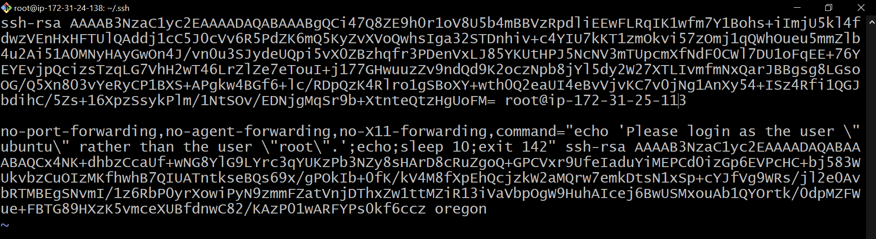



**Review it by cat.**

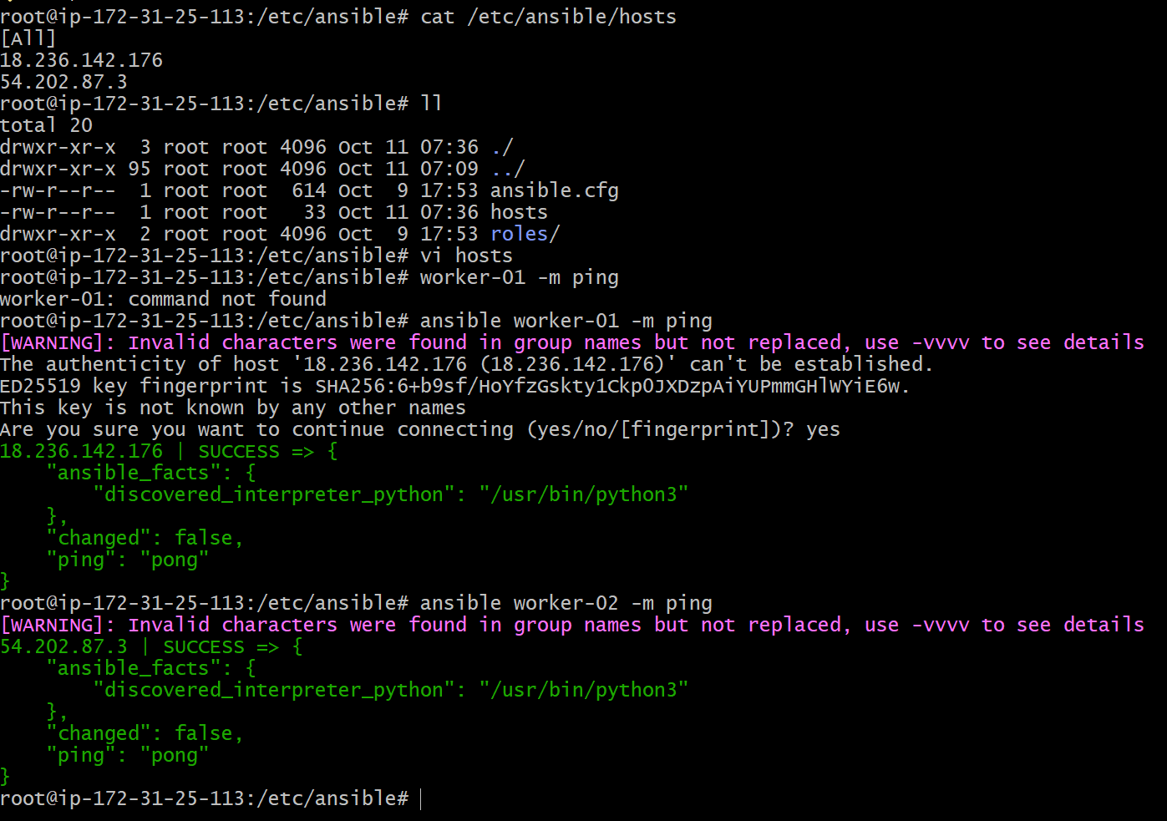

**check both workers by ping and got success as PONG**

3) Execute the adhoc command shared in #dvps-cloud-documents Channel

Inventree

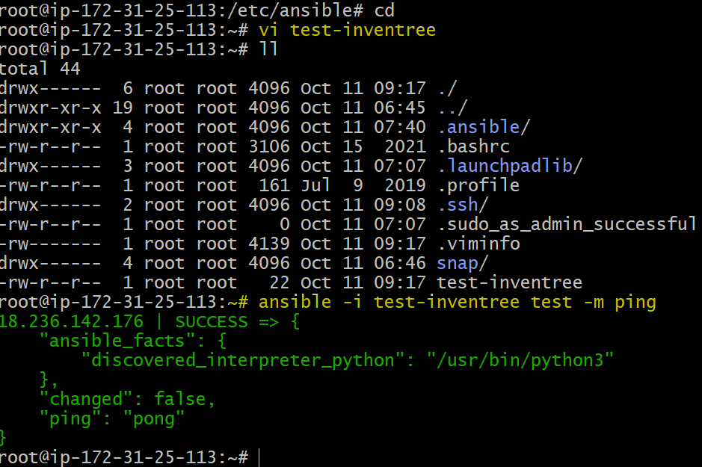

Setup module

uptime

check the free memory

**What if you do not have SSH key-based? How to pass username and password?**

**ansible all -m ping --user=root --ask-pass**

**with no password**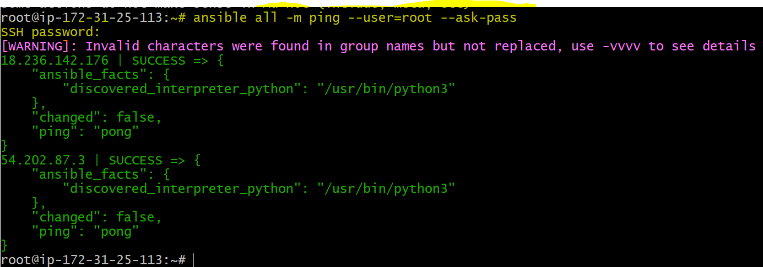

**to Install a package using yum command**

**Update a shell by using command :** **ansible all -m shell -a "apt-get -y update"**

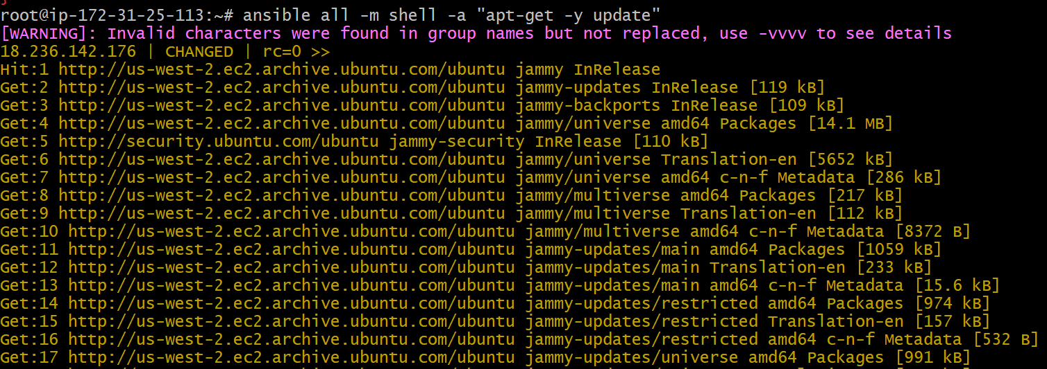

**Install Apache 2 in master server  
Install a package using apt command  
command: ansible all -m apt -a "name=apache2 state=latest**

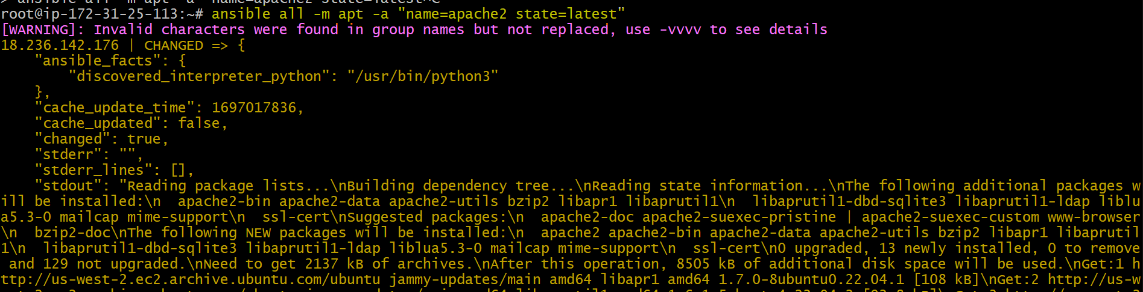

**then start it  
# Start or stop the service**

**# To Start**

**ansible all -m service -a "name=apache2 state=started enabled=yes"**

Worker 1

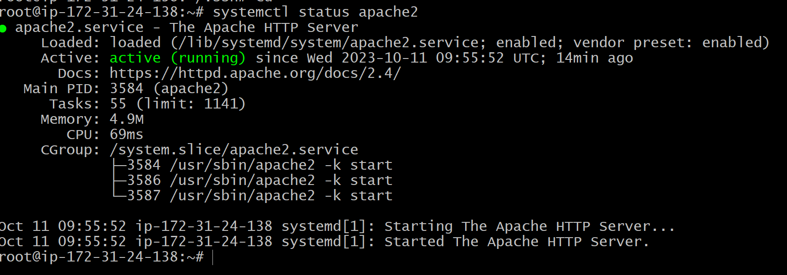

**then in both workers Apache2 got installed (worker1)**

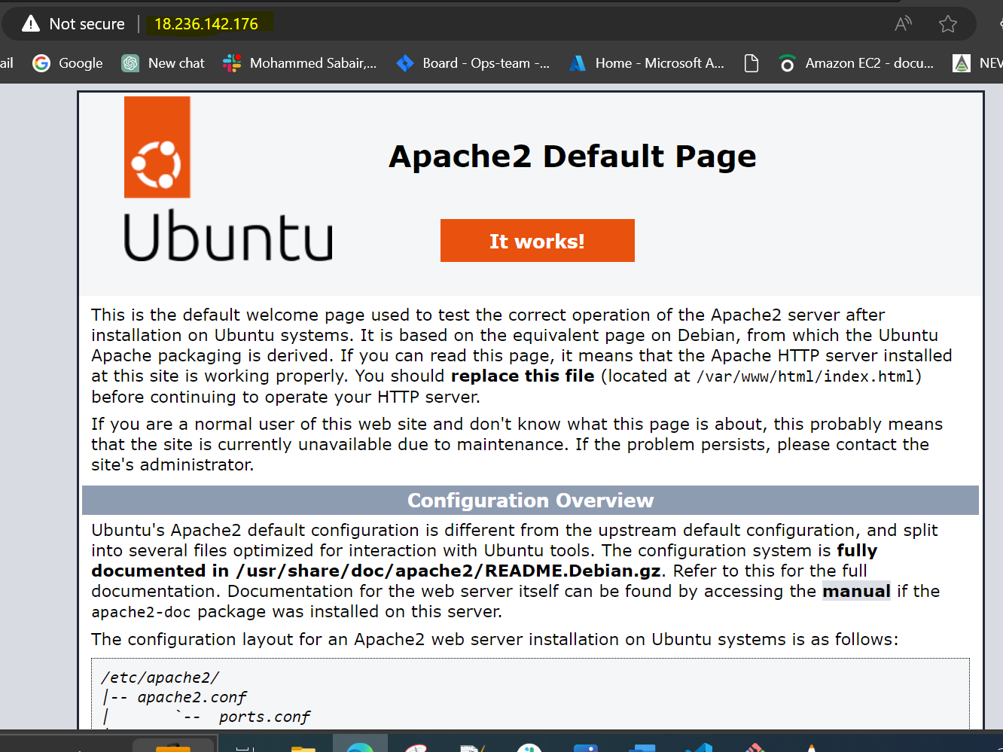

**(worker2)**

